Computational Methods Assignment

Task 1

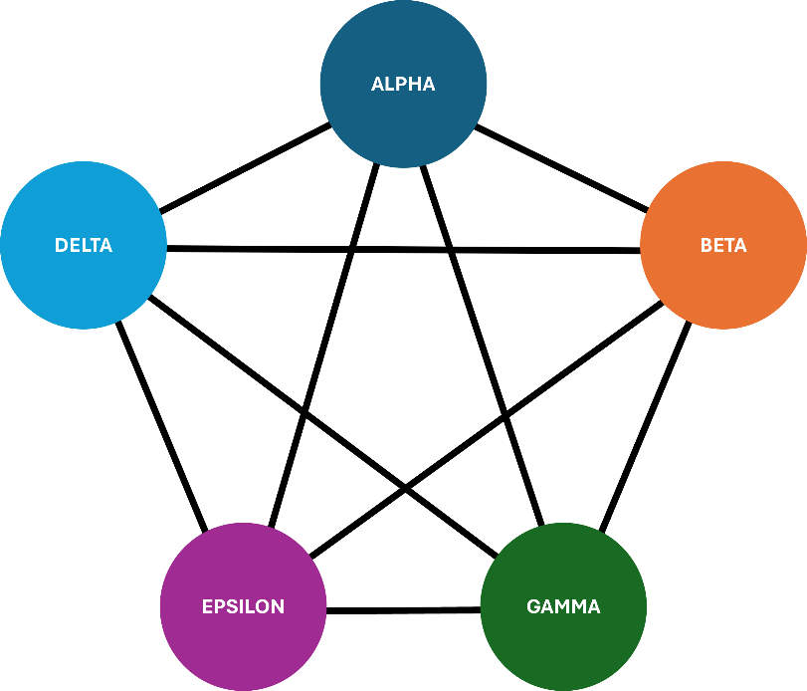

I created a spreadsheet which multiplies and sums up the total distance, weight and fuel cost for each combination, which you can view in the Task 1 folder under Assessment Brute Forcing.xlsx to see my formulas and layout.

After I had finished writing out every combination, I used the min function and inputted every total fuel cost cell, which gave me the result "69,000" so I used ctrl + f to find the combination with a total of 69,000 and then I had found the cheapest possible route.

I'm assuming that the planets are geo-stationary, that the ship has no prior cargo inside, that no other planets have been visited before the first planet in each route and that when the route ends, they visit no more planets alongside not going to each planet more than once.

Brute forcing these routes is not optimal as the runtime of the algorithm grows exponentially large, seen through the time-complexity O(mn). It's inefficient compared to other algorithms that are designed to take advantage of patterns or insights that could reduce the search size.

Doing this by hand is especially bad because alongside the time complexity, it is also prone to human error. I've already had to go back through my spreadsheet multiple times due to growing bored and tired and making mistakes.